Request for Bids for Vista Village Residential Rehabilitation Project

To Prospective Respondents:
You are invited to submit a quote for the rehabilitation of five residential units and landscaping improvement at Vista Village, as called for in the Project Description and Scope of work. The improvements are to be made for and under contract with West Valley Community Services, the owner of the property. Disbursements of funds for the improvements will be approved by the owner and a representative of the City of Cupertino’s Housing Department.
Please read all of the information in this package. Directions to submit a response are included in the bid package.
THE FOLLOWING LANGUAGE AND ADDENDUMS ARE IMPOSED TO MEET THE FEDERAL REQUIREMENTS OF THE CDBG PROGRAM. THESE REQUIREMENTS ARE IN ADDITION TO ANY OTHER PROCUREMENT AND CONTRACTING REQUIREMENTS OF YOUR AGENCY.
1) “This is a State and Federal prevailing wage project. The attached HUD Form 4010, Labor Federal Standards Provisions, and Federal; https://beta.sam.gov/search?index=wd&keywords=&is_active=true&sort=-modifiedDate&date_filter_index=0&date_rad_selection=date&wdType=dbra&construction_type=Residential&state=CA&county=16357&page=1 Wage Decision CA20200019 Modification #26 dated November 5, 2020apply to the work of this project. These wages may change ten (10) days prior to bid opening. In the event of a change in the wage determination, an addendum will be issued with new determination.
In addition, this project is subject to California State prevailing wages and public works project requirements. The successful low bidder must be a California licensed contractor and must be able to provide proof of general liability insurance and workers compensation insurance. Pursuant to Section 1773 of the CA Labor Code, the general prevailing wage rates in the county in which the work is to be done have been determined by the Director of the California Department of Industrial Relations. These wages are set forth in the CA General Prevailing Wage Rates for this project, available at the California Department of Industrial Relations’ Internet web site at: http://www.dir.ca.gov. The residential rates apply to this project. In payment of labor, the Contractor shall comply with the provisions of Labor Code Sections 1770 to 1781. All labor is required to be paid at a rate not less than the greater of the locked-in Federal Davis-Bacon Prevailing Wage or State Prevailing Wage made by the California Director of Industrial Relations.
The successful low bidder will be required to register with the California Department of Industrial Relations as a registered Public Works Contractor, if the selected bidder is not currently registered. This project is subject to enforcement by the U.S. Department of Housing and Urban Development (HUD), U.S. Department of Labor (DOL) and the State’s DIR.”
2) “The Contractor will use its best efforts to afford minority-owned and women-owned business enterprises the maximum practicable opportunity to participate in the construction of the project. The Contractor shall, at a minimum, notify applicable minority-owned and women-owned business firms located in Santa Clara County of bid opportunities for the project. Documentation of such notifications shall be maintained by the Contractor and made available to the County as requested.”
3.) “The contractor will not discriminate against any employee or applicant for employment because of race, color, religion, sex, sexual orientation, gender identity or national origin. The contractor will comply with all provisions of Executive Order 11246 of September 24, 1965 and of the rules, regulations, and relevant orders of the Secretary of Labor. "

4) (If the construction contract exceeds $100,000.) “The work performed on the project is subject to the requirements of Section 3 of the Housing and Urban Development Act of 1968, as amended, 12 U.S.C. 1701. Section 3 requires that to the greatest extent feasible, opportunities for training and employment be given to lower income residents of the project area, and agreements for work in connection with the project be awarded to business concerns which are located in, or owned in substantial part by persons residing in, the area of the project.”

5) Review your loan documents or project agreement to ensure that the appropriate level of insurance is included.

RFB DUE DATE: October 25th by 4pm
The bid response document must be submitted in a sealed envelope with required documents to West Valley Community Services Property Management Office at West Valley Community Services, 10104 Vista Drive, Cupertino, CA 95014. The bid can be mailed to above address but needs to be received by October 25th, 2021. Any bids received after October 25th will not be accepted.
_____________________________________________________________________________________
SCHEDULE
∙ Virtual walk through and project scope October 11th - October 15th, 2021
∙ Bid opening October 25th, 2021 at 4:15 pm – 5:00 pm
∙ Organization Selection/Council Approval: October 29th, 2021
∙ Effective Date of Agreement: November 1st, 2021
∙ Project Completion: June 30, 2022
MINIMUM REQUIREMENT
- Contractor’s qualification and experience in construction of residential housing for HUD and CDBG.
- Contractors extent of financial resources available to perform the work
- Contractors experience in completing projects of a similar nature for HUD CDBG programs
- Insurance in the following amounts
    - General Liability, 1,000,000 limits
    - Automobile Liability, 1,000,000 limits
    - Worker’s Compensation, Statutory by California Law
- Be lien and judgement free
- Comply with the Davis Bacon Prevailing Wage act as proposed by Department of Labor Regulations. For all contracted and subcontracted work under this RFB, the wages are required to be paid at a rate not less than the greater of the locked-in Federal Davis-Bacon Prevailing Wage or State Prevailing Wage made by the California Director of Industrial Relations.
- Locally owned business with experience with low-income residents in the project area.

REQUIREMENTS FOR RFB SUBMITTAL
A complete RFB package MUST include the following:
- Checklist form
- Copies of all licenses, certifications and insurances as part of the RFB
- Completed and signed Contractor Qualification-APPENDIX A
- A detailed Scope of Work and work description with fee structure- APPENDIX B-QUOTE FORM
- Detailed Itemized Budget- APPENDIX C
- Procurement and Conflict of Interest form- APPENDIX D
- Section 3 Clause form-APPENDIX E
- Davis Bacon Provisions form-APPENDIX F
- PW Contract Language form-APPENDIX G

CONTRACT TIME POLICY: If a contractor fails to complete a project within the contract period, the contractor will receive a verbal and written warning and no quotes for additional projects will be accepted from him/her until that job is completed. The completion date will be established by the original contract documents and properly executed change order. Extensions of contract time will be approved only as outlined by the contract documents, and for the reasons described therein. All work by the contractor must be completed by June 30, 2021.

CRITERIA FOR DETERMINATION
Subject to the conditions of these Bid Documents, West Valley Community Services will award the contract, if an award is made, to the lowest responsive and responsible bidder. In determining whether the bidder is responsible, Wet Valley Community Services will use the criteria set forth below:
- Bidder must have the ability, capacity, experience and skill to perform the work, or provide the goods and/or services in accordance with the bid specifications
- Bidder must have the ability to perform the contract within the time specified
- Bidder must have the equipment, facilities and resources of such capacity and location to enable the bidder to perform the contract
- Bidder must have the ability to provide, as required, future maintenance, repair, parts and service for the use of goods purchased
- Bidder must have a record of satisfactory or better performance under prior contracts with West Valley Community Services or others; and
- Has complied with laws, regulations, guidelines and orders governing prior or existing contracts

REJECTION OF BIDS
West Valley Community Services reserves the right to reject any and all bids; and further reserves the right to reject any bids that are found to be non-responsive or submitted by a bidder that is not responsible.
AGENCY DESCRIPTION
For more than 40 years, West Valley Community Services has been providing basic needs services to the almost 22,000 men, women, and children living in poverty in the west valley communities of Cupertino, Los Gatos, Monte Sereno, Saratoga, and West San Jose in Santa Clara County, California. West Valley Community Services is our community's safety net, and we exist to ensure that low income and homeless individuals and families receive the support and services they need to build the foundation for a brighter future. West Valley Community Services offers a range of safety net services to clients, including a food pantry, affordable housing, emergency financial assistance, a mobile food pantry, financial coaching, family support, case management, and referral services. We also partner with county agencies to ensure clients have access to public health and food assistance benefits. Our programs target families with children, at-risk youth, seniors, individuals, and disabled adults who are extremely low-income, living on a fixed-income, homeless or are at risk of becoming homeless.

PROJECT DESCRIPTION
This project will help repair residential units within the Vista Village Below Market Rate rental complex. The complex owned by West Valley Community Services was built in 2002. The complex features one bedroom and two bedroom units. The repair includes interior repairs of 5 one-bedroom units that have residents living there for more than 10 years and landscaping improvement. The repairs include laminate flooring in the living room; vinyl flooring in the kitchen, dining area, and bathroom; painting of the units and the kitchen cabinets; new kitchen countertop, new appliances, new toilets, and new laminate flooring in the bedroom and new light fixtures. For the landscaping; new concrete pads and repair the drainage system.

SCOPE OF SERVICE
This project will help revitalize the Vista Village affordable housing complex with various repairs and renovations. This project aligns with the agency's vision of transforming the lives of low-income households by providing a safe and affordable home.
The total project scope includes the following:
Repair five housing units, including new laminate (or equivalent product) flooring, interior paint, window covers, complete kitchen remodel, and complete bathroom remodel. The residents of these units moved into their apartment in 2002 when the Vista Village complex was first built, and no significant repairs have been conducted since then. There are five units (one one-bedroom unit) that require these repairs. The landscaping in the back of these units need concrete pads and repair of the drainage in this area. In the contract West Valley Community Services will provide motel relocation expenses for the residents currently occupying these units. West Valley Community Services is looking at a minimum of 14 day of motel stay for each resident of each unit while their unit is being renovated.

CHECKLIST FORM

- A copy of current General Contractor’s license (C or better)
- A copy of your Certificate of General Liability Insurance
- A copy of Workman’s Compensation Insurance, if you have employees
- APPENDIX A- Completed Contractor Request for Qualification
- APPENDIX B- Quote Form
- APPENDIX C- Detailed Itemized Budget
- APPENDIX D- Procurement and Conflict of Interest form
- APPENDIX E- Section 3 Clause form
- APPENDIX F- Davis Bacon Provisions form
- APPENDIX G- PW Contract Language form
- APPENDIX H- Residential Davis Bacon Rate form

Appendix A
Contractor Qualification
Fillable Form
CONTRACTOR INFORMATION
- Name of the Contractor:
- Company Name Owner(s)
- Address City, State & Zip
  - Phone:
  - Cellular Phone:
  - Email Address:
- Fax Federal Tax ID # or Owner’s Social Security #
- Year incorporated: How many years of operation:
- Number of employees and annual gross revenue of company
  - Employees:
  - Annual Gross Revenue:
- Contracts currently awarded or active ( List these, showing gross amount for each contract and the approximate date of completion)

Name of the Project | Gross Amount | Length of the projects | Completion Date

- General description of the work performed by your company:
- Have you ever failed to complete any work awarded to you? Yes ☐ No ☐
If yes, please explain:
- Have you ever defaulted on a contract? Yes ☐ No ☐
If yes, please explain:
- Have you ever debarred or suspended from CDBG contracting? Yes ☐ No ☐
If yes, please explain:
- Do you pay prevailing wage as prescribed under the Davis Bacon Act?
Yes☐ No☐ When required☐
- Experience in construction work similar to this project
- Do you have the following current levels of insurance? Yes☐ No☐
    - General Liability, 1000,000 limits
    - Automobile Liability, 1000,000 limits
    - Worker’s Compensation, 1000,000 Statutory by California Law

- References: Former clients and Project description
Company Name:
Contact Person Name:
Address:
Phone:
Email:
Description of work:
Services dates:

Company Name:
Contact Person Name:
Address:
Phone:
Email:
Description of work:
Services dates:

Company Name:
Contact Person Name:
Address:
Phone:
Email:
Description of work
Services dates

Appendix B
QUOTE FORMS

TOTAL QUOTE DOLLARS _____________

WORK TO BE COMPLETED IN _____________ CALENDAR DAYS

WARRANTY PERIOD _____________ (Initial)

The undersigned hereby proposes to furnish all labor and materials and to perform all the work required for the complete and prompt execution of all items described or shown in or reasonably implied from the RFB documents, including the Work Description and General Specifications Manual for the general, mechanical and electrical work, for the following total sum, which includes all state and local taxes, permitting fees and other costs normally payable in respect of such work.
If awarded the contract, the undersigned hereby agrees to sign said Contract and to begin work within thirty (30) days from the signing of the Rehabilitation Construction Contract.
I hereby certify that the information set forth above is true and complete to the best of my knowledge.

Signature Date:

Printed Name: Company Name:

Appendix C
Sample Itemized Budget

DESCRIPTION | VENDOR SUBCONTRACTOR/CONTRACTOR | ESTIMATED COST
 |  | LABOR | MATERIALS | TOTAL
GENERAL Contractor
Plan Review |  |  |  | $ -
Administrative Costs |  |  |  | $ -
Flooring
Living Room |  |  |  | $ -
Bedroom |  |  |  | $ -
Kitchen |  |  |  | $ -
Bathroom |  |  |  | $ -
stairway & landing if any
Kitchen Area
Cabinets |  |  |  | $ -
Countertop |  |  |  | $ -
Appliances (dishwasher, cooktop, refrigerator, hood range) |  |  |  | $ -
Light fixtures |  |  |  | $ -
Bathroom Area |  |  |  | $ -
(complete remodel)
Painting
Entire Interior of the units |  |  |  | $ -
Miscellaneous
Subtotal |  | $ - | $ - | $ -

Appendix D
Procurement and Conflict of Interest Form

☐ I will be able to comply with the CDBG procurement requirement (24 CFR Part 84 and 85) and as stated below

- Sealed bids (Formal Advertising) should be used for all construction contracts or for goods costing more than $100,000

☐ I have no conflict of interest as state in the 24 CFR § 570 611 as part of the CDBG procurement requirement.
Any person who is an employee, agent, consultant, officer or elected of a recipient or sub recipient does not exercise any functions or responsibilities with respect to CDBG activities and is in no position to participate in the decision making process or gains inside information with regard this project.

Signature ____________ Date:

Printed Name: Company Name:

APPENDIX E
Section 3 Clause
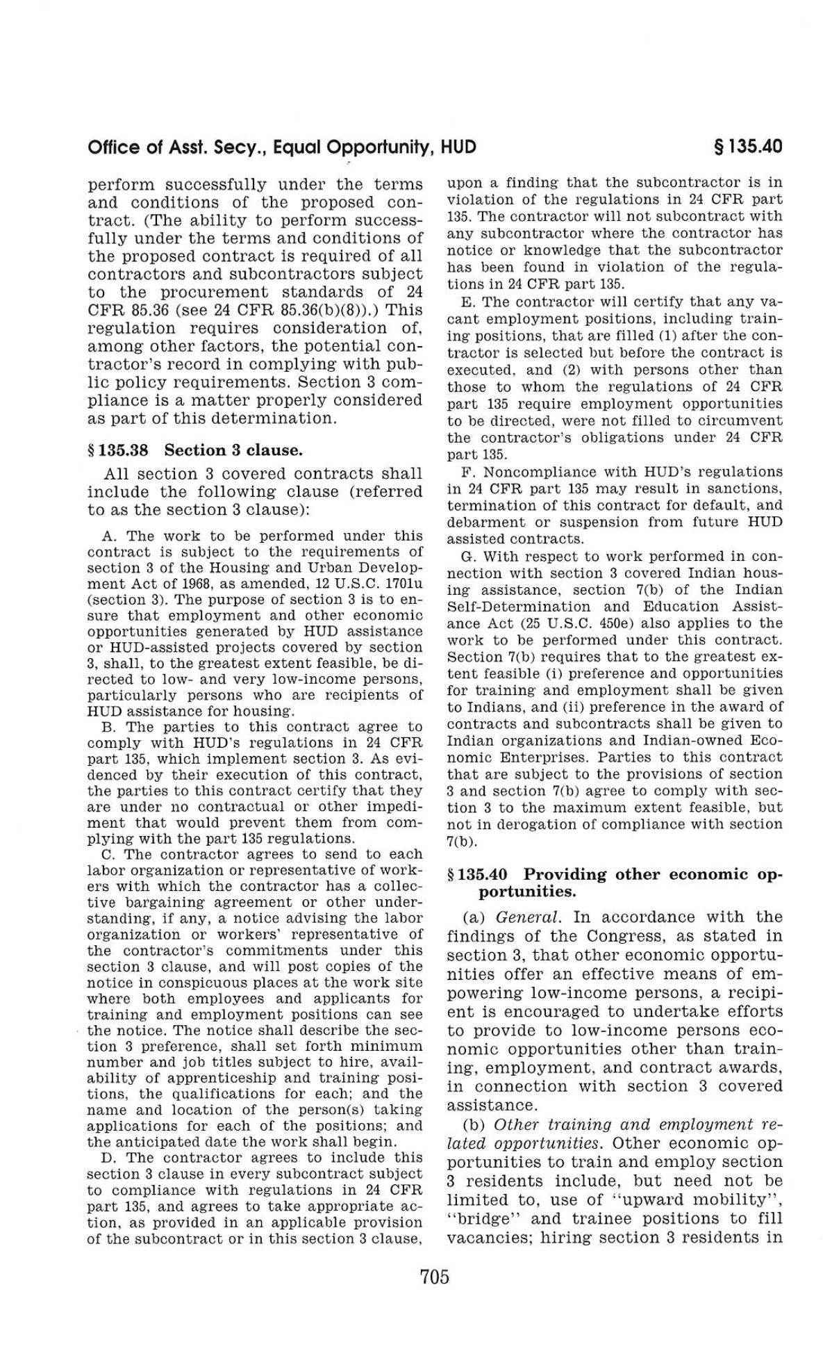
Signature ____________ Date:

Printed Name: Company Name:
APPENDIX F

Davis Bacon Provisions:

(1) Minimum wages. (i) All laborers and mechanics employed or working upon the site of the work (or under the United States Housing Act of 1937 or under the Housing Act of 1949 in the construction or development of the project), will be paid unconditionally and not less often than once a week, and without subsequent deduction or rebate on any account (except such payroll deductions as are permitted by regulations issued by the Secretary of Labor under the Copeland Act (29 CFR part 3)), the full amount of wages and bona fide fringe benefits (or cash equivalents thereof) due at time of payment computed at rates not less than those contained in the wage determination of the Secretary of Labor which is attached hereto and made a part hereof, regardless of any contractual relationship which may be alleged to exist between the contractor and such laborers and mechanics.

Contributions made or costs reasonably anticipated for bona fide fringe benefits under section 1(b)(2) of the Davis-Bacon Act on behalf of laborers or mechanics are considered wages paid to such laborers or mechanics, subject to the provisions of paragraph (a)(1)(iv) of this section; also, regular contributions made or costs incurred for more than a weekly period (but not less often than quarterly) under plans, funds, or programs which cover the particular weekly period, are deemed to be constructively made or incurred during such weekly period. Such laborers and mechanics shall be paid the appropriate wage rate and fringe benefits on the wage determination for the classification of work actually performed, without regard to skill, except as provided in Sec. 5.5(a)(4). Laborers or mechanics performing work in more than one classification may be compensated at the rate specified for each classification for the time actually worked therein: Provided, that the employer's payroll records accurately set forth the time spent in each classification in which work is performed. The wage determination
(including any additional classification and wage rates conformed under paragraph (a)(1)(ii) of this section) and the Davis-Bacon poster (WH-1321) shall be posted at all times by the contractor and its subcontractors at the site of the work in a prominent and accessible place where it can be easily seen by the workers.

(ii)(A) The contracting officer shall require that any class of laborers or mechanics, including helpers, which is not listed in the wage determination and which is to be employed under the contract shall be classified in conformance with the wage determination. The contracting officer shall approve an additional classification and wage rate and fringe benefits therefore only when the following criteria have been met:
(1) The work to be performed by the classification requested is not performed by a classification in the wage determination; and (2) The classification is utilized in the area by the construction industry; and
(3) The proposed wage rate, including any bona fide fringe benefits, bears a reasonable relationship to the wage rates contained in the wage determination.

(B) If the contractor and the laborers and mechanics to be employed in the classification (if known), or their representatives, and the contracting officer agree on the classification and wage rate (including the amount designated for fringe benefits where appropriate), a report of the action taken shall be sent by the contracting officer to the Administrator of the Wage and Hour Division, Employment Standards Administration, U.S. Department of Labor, Washington, DC 20210. The Administrator, or an authorized representative, will approve, modify, or disapprove every additional classification action within 30 days of receipt and so advise the contracting officer or will notify the contracting officer within the 30-day period that additional time is necessary.

(C) In the event the contractor, the laborers or mechanics to be employed in the classification or their representatives, and the contracting officer do not agree on the proposed classification and wage rate (including the amount designated for fringe benefits, where appropriate), the contracting officer shall refer the questions, including the views of all interested parties and the recommendation of the contracting officer, to the Administrator for determination. The Administrator, or an authorized representative, will issue a determination within 30 days of receipt and so advise the contracting officer or will notify the contracting officer within the 30-day period that additional time is necessary.

(D) The wage rate (including fringe benefits where appropriate) determined pursuant to paragraphs (a)(1)(ii) (B) or (C) of this section, shall be paid to all workers performing work in the classification under this contract from the first day on which work is performed in the classification.
(iii) Whenever the minimum wage rate prescribed in the contract for a class of laborers or mechanics includes a fringe benefit which is not expressed as an hourly rate, the contractor shall either pay the benefit as stated in the wage determination or shall pay another bona fide fringe benefit or an hourly cash equivalent thereof.
(iv) If the contractor does not make payments to a trustee or other third person, the contractor may consider as part of the wages of any laborer or mechanic the amount of any costs reasonably anticipated in providing bona fide fringe benefits under a plan or program, Provided, That the Secretary of Labor has found, upon the written request of the contractor, that the applicable standards of the Davis-Bacon Act have been met. The Secretary of Labor may require the contractor to set aside in a separate account assets for the meeting of obligations under the plan or program.

(2) Withholding. The WEST VALLEY COMMUNITY SERVICES shall upon its own action or upon written request of an authorized representative of the Department of Labor withhold or cause to be withheld from the contractor under this contract or any other Federal contract with the same prime contractor, or any other federally- assisted contract subject to Davis-Bacon prevailing wage requirements, which is held by the same prime contractor, so much of the accrued payments or advances as may be considered necessary to pay laborers and mechanics, including apprentices, trainees, and helpers, employed by the contractor or any subcontractor the full amount of wages required by the contract. In the event of failure to pay any laborer or mechanic, including any apprentice, trainee, or helper, employed or working on the site of the work (or under the United States Housing Act of 1937 or under the Housing Act of 1949 in the construction or development of the project), all or part of the wages required by the contract, the (Agency) may, after written notice to the contractor, sponsor, applicant, or owner, take such action as may be necessary to cause the suspension of any further payment, advance, or guarantee of funds until such violations have ceased.

(3) Payrolls and basic records. (i) Payrolls and basic records relating thereto shall be maintained by the contractor during the course of the work and preserved for a period of three years thereafter for all laborers and mechanics working at the site of the work (or under the United States Housing Act of 1937, or under the Housing Act of 1949, in the construction or development of the project). Such records shall contain the name, address, and social security number of each such worker, his or her correct classification, hourly rates of wages paid (including rates of contributions or costs anticipated for bona fide fringe benefits or cash equivalents thereof of the types described in section 1(b)(2)(B) of the Davis-Bacon Act), daily and weekly number of hours worked, deductions made and actual wages paid. Whenever the Secretary of Labor has found under 29 CFR 5.5(a)(1)(iv) that the wages of any laborer or mechanic include the amount of any costs reasonably anticipated in providing benefits under a plan or program described in section 1(b)(2)(B) of the Davis-Bacon Act, the contractor shall maintain records which show that the commitment to provide such benefits is enforceable, that the plan or program is financially responsible, and that the plan or program has been communicated in writing to the laborers or mechanics affected, and record which show the costs anticipated or the actual cost incurred in providing such benefits. Contractors employing apprentices or trainees under approved programs shall maintain written evidence of the registration of apprenticeship programs and certification of trainee programs, the registration of the apprentices and trainees, and the ratios and wage rates prescribed in the applicable programs.

(ii)(A) The contractor shall submit weekly for each week in which any contract work is performed a copy of all payrolls to the (write in name of appropriate federal agency) if the agency is a party to the contract, but if the agency is not such a party, the contractor will submit the payrolls to the applicant, sponsor, or owner, as the case may be, for transmission to the (write in name of agency). The payrolls submitted shall set out accurately and completely all of the information required to be maintained under 29 CFR 5.5(a)(3)(i), except that full social security numbers and home addresses shall not be included on weekly transmittals. Instead the payrolls shall only need to include an individually identifying number for each employee (e.g. the last four digits of the employee's social security number). The required weekly payroll information may be submitted in any form desired. Optional Form WH-347 is available for this purpose from the Wage and Hour Division Web site at http://www.dol.gov/esa/whd/forms/wh347instr.htm or its successor site. The prime contractor is responsible for the submission of copies of payrolls by all subcontractors. Contractors and subcontractors shall maintain the full social security number and current address of each covered worker, and shall provide them upon request to the (write in name of appropriate federal agency) if the agency is a party to the contract, but if the agency is not such a party, the contractor will submit them to the applicant, sponsor, or owner, as the case may be, for transmission to the (write in name of agency), the contractor, or the Wage and Hour Division of the Department of Labor for purposes of an investigation or audit of compliance with prevailing wage requirements. It is not a violation of this section for a prime contractor to require a subcontractor to provide addresses and social security numbers to the prime contractor for its own records, without weekly submission to the sponsoring government agency (or the applicant, sponsor, or owner).

(B) Each payroll submitted shall be accompanied by a ``Statement of
Compliance,'' signed by the contractor or subcontractor or his or her agent who pays or supervises the payment of the persons employed under the contract and shall certify the following:

(1) That the payroll for the payroll period contains the information required to be provided under Sec. 5.5 (a)(3)(ii) of Regulations, 29 CFR part 5, the appropriate information is being maintained under Sec. 5.5 (a)(3)(i) of Regulations, 29 CFR part 5, and that such information is correct and complete;
(2) That each laborer or mechanic (including each helper, apprentice, and trainee) employed on the contract during the payroll period has been paid the full weekly wages earned, without rebate, either directly or indirectly, and that no deductions have been made either directly or indirectly from the full wages earned, other than permissible deductions as set forth in Regulations, 29 CFR part 3;

(3) That each laborer or mechanic has been paid not less than the applicable wage rates and fringe benefits or cash equivalents for the classification of work performed, as specified in the applicable wage determination incorporated into the contract.

(C) The weekly submission of a properly executed certification set forth on the reverse side of Optional Form WH-347 shall satisfy the requirement for submission of the ``Statement of Compliance'' required by paragraph (a)(3)(ii)(B) of this section.

(D) The falsification of any of the above certifications may subject the contractor or subcontractor to civil or criminal prosecution under section 1001 of title 18 and section 231 of title 31 of the United States Code.

(iii) The contractor or subcontractor shall make the records required under paragraph (a)(3)(i) of this section available for inspection, copying, or transcription by authorized representatives of the (write the name of the agency) or the Department of Labor, and shall permit such representatives to interview employees during working hours on the job. If the contractor or subcontractor fails to submit the required records or to make them available, the Federal agency may, after written notice to the contractor, sponsor, applicant, or owner, take such action as may be necessary to cause the suspension of any further payment, advance, or guarantee of funds. Furthermore, failure to submit the required records upon request or to make such records available may be grounds for debarment action pursuant to 29 CFR 5.12.

(4) Apprentices and trainees—
(i) Apprentices. Apprentices will be permitted to work at less than the predetermined rate for the work they performed when they are employed pursuant to and individually registered in a bona fide apprenticeship program registered with the U.S. Department of Labor, Employment and Training Administration, Office of Apprenticeship Training, Employer and Labor Services, or with a State Apprenticeship Agency recognized by the Office, or if a person is employed in his or her first 90 days of probationary employment as an apprentice in such an apprenticeship program, who is not individually registered in the program, but who has been certified by the Office of Apprenticeship Training, Employer and Labor Services or a State Apprenticeship Agency (where appropriate) to be eligible for probationary employment as an apprentice. The allowable ratio of apprentices to journeymen on the job site in any craft classification shall not be greater than the ratio permitted to the contractor as to the entire work force under the registered program. Any worker listed on a payroll at an apprentice wage rate, who is not registered or otherwise employed as stated above, shall be paid not less than the applicable wage rate on the wage determination for the classification of work actually performed. In addition, any apprentice performing work on the job site in excess of the ratio permitted under the registered program shall be paid not less than the applicable wage rate on the wage determination for the work actually performed. Where a contractor is performing construction on a project in a locality other than that in which its program is registered, the ratios and wage rates (expressed in percentages of the journeyman's hourly rate) specified in the contractor's or subcontractor's registered program shall be observed. Every apprentice must be paid at not less than the rate specified in the registered program for the apprentice's level of progress, expressed as a percentage of the journeymen hourly rate specified in the applicable wage determination. Apprentices shall be paid fringe benefits in accordance with the provisions of the apprenticeship program. If the apprenticeship program does not specify fringe benefits, apprentices must be paid the full amount of fringe benefits listed on the wage determination for the applicable classification. If the Administrator determines that a different practice prevails for the applicable apprentice classification, fringes shall be paid in accordance with that determination. In the event the Office of Apprenticeship Training, Employer and Labor Services, or a State Apprenticeship Agency recognized by the Office, withdraws approval of an apprenticeship program, the contractor will no longer be permitted to utilize apprentices at less than the applicable predetermined rate for the work performed until an acceptable program is approved.

(ii) Trainees. Except as provided in 29 CFR 5.16, trainees will not be permitted to work at less than the predetermined rate for the work performed unless they are employed pursuant to and individually registered in a program which has received prior approval, evidenced by formal certification by the U.S. Department of Labor, Employment and Training Administration. The ratio of trainees to journeymen on the job site shall not be greater than permitted under the plan approved by the Employment and Training Administration. Every trainee must be paid at not less than the rate specified in the approved program for the trainee's level of progress, expressed as a percentage of the journeyman hourly rate specified in the applicable wage determination. Trainees shall be paid fringe benefits in accordance with the provisions of the trainee program. If the trainee program does not mention fringe benefits, trainees shall be paid the full amount of fringe benefits listed on the wage determination unless the Administrator of the Wage and Hour Division determines that there is an apprenticeship program associated with the corresponding journeyman wage rate on the wage determination which provides for less than full fringe benefits for apprentices. Any employee listed on the payroll at a trainee rate who is not registered and participating in a training plan approved by the Employment and Training Administration shall be paid not less than the applicable wage rate on the wage determination for the classification of work actually performed. In addition, any trainee performing work on the job site in excess of the ratio permitted under the registered program shall be paid not less than the applicable wage rate on the wage determination for the work actually performed. In the event the Employment and Training Administration withdraws approval of a training program, the contractor will no longer be permitted to utilize trainees at less than the applicable predetermined rate for the work performed until an acceptable program is approved.

(iii) Equal employment opportunity. The utilization of apprentices, trainees and journeymen under this part shall be in conformity with the equal employment opportunity requirements of Executive Order 11246, as amended, and 29 CFR part 30.

(5) Compliance with Copeland Act requirements. The contractor shall comply with the requirements of 29 CFR part 3, which are incorporated by reference in this contract.

(6) Subcontracts. The contractor or subcontractor shall insert in any subcontracts the clauses contained in 29 CFR 5.5(a)(1) through (10) and such other clauses as the (write in the name of the Federal agency) may by appropriate instructions require, and also a clause requiring the subcontractors to include these clauses in any lower tier subcontracts.
The prime contractor shall be responsible for the compliance by any subcontractor or lower tier subcontractor with all the contract clauses in 29 CFR 5.5.
(7) Contract termination: debarment. A breach of the contract clauses in 29 CFR 5.5 may be grounds for termination of the contract, and for debarment as a contractor and a subcontractor as provided in 29 CFR 5.12.

(8) Compliance with Davis-Bacon and Related Act requirements. All rulings and interpretations of the Davis-Bacon and Related Acts contained in 29 CFR parts 1, 3, and 5 are herein incorporated by reference in this contract.

(9) Disputes concerning labor standards. Disputes arising out of the
labor standards provisions of this contract shall not be subject to the general disputes clause of this contract. Such disputes shall be resolved in accordance with the procedures of the Department of Labor set forth in 29 CFR parts 5, 6, and 7. Disputes within the meaning of this clause include disputes between the contractor (or any of its subcontractors) and the contracting agency, the U.S. Department of Labor, or the employees or their representatives.

(10) Certification of eligibility. (i) By entering into this contract, the contractor certifies that neither it (nor he or she) nor any person or firm who has an interest in the contractor's firm is a person or firm ineligible to be awarded Government contracts by virtue of section 3(a) of the Davis-Bacon Act or 29 CFR 5.12(a)(1).

(ii) No part of this contract shall be subcontracted to any person or firm ineligible for award of a Government contract by virtue of section 3(a) of the Davis-Bacon Act or 29 CFR 5.12(a)(1).

(iii) The penalty for making false statements is prescribed in the
U.S. Criminal Code, 18 U.S.C. 1001.

(b) Contract Work Hours and Safety Standards Act. The Agency Head shall cause or require the contracting officer to insert the following clauses set forth in paragraphs (b)(1), (2), (3), and (4) of this section in full in any contract in an amount in excess of $100,000 and subject to the overtime provisions of the Contract Work Hours and Safety
Standards Act. These clauses shall be inserted in addition to the clauses required by Sec. 5.5(a) or 4.6 of part 4 of this title. As used in this paragraph, the terms laborers and mechanics include watchmen and guards.

(1) Overtime requirements. No contractor or subcontractor contracting for any part of the contract work which may require or involve the employment of laborers or mechanics shall require or permit any such laborer or mechanic in any workweek in which he or she is employed on such work to work in excess of forty hours in such workweek unless such laborer or mechanic receives compensation at a rate not less than one and one-half times the basic rate of pay for all hours worked in excess of forty hours in such workweek.

(2) Violation; liability for unpaid wages; liquidated damages. In the event of any violation of the clause set forth in paragraph (b)(1) of this section the contractor and any subcontractor responsible therefor shall be liable for the unpaid wages. In addition, such contractor and subcontractor shall be liable to the United States (in the case of work done under contract for the District of Columbia or a territory, to such District or to such territory), for liquidated damages. Such liquidated damages shall be computed with respect to each individual laborer or mechanic, including watchmen and guards, employed in violation of the clause set forth in paragraph (b)(1) of this section, in the sum of $10 for each calendar day on which such individual was required or permitted to work in excess of the standard workweek of forty hours without payment of the overtime wages required by the clause set forth in paragraph (b)(1) of this section.

(3) Withholding for unpaid wages and liquidated damages. The WEST VALLEY COMMUNITY SERVICES shall upon its own action or upon written request of an authorized representative of the Department of Labor withhold or cause to be withheld, from any moneys payable on account of work performed by the contractor or subcontractor under any such contract or any other Federal contract with the same prime contractor, or any other federally-assisted contract subject to the Contract Work Hours and Safety Standards Act, which is held by the same prime contractor, such sums as may be determined to be necessary to satisfy any liabilities of such contractor or subcontractor for unpaid wages and liquidated damages as provided in the clause set forth in paragraph (b)(2) of this section.

(4) Subcontracts. The contractor or subcontractor shall insert in any subcontracts the clauses set forth in paragraph (b)(1) through (4) of this section and also a clause requiring the subcontractors to include these clauses in any lower tier subcontracts. The prime contractor shall be responsible for compliance by any subcontractor or lower tier subcontractor with the clauses set forth in paragraphs (b)(1) through (4) of this section.

(c) In addition to the clauses contained in paragraph (b), in any contract subject only to the Contract Work Hours and Safety Standards Act and not to any of the other statutes cited in Sec. 5.1, the Agency Head shall cause or require the contracting officer to insert a clause requiring that the contractor or subcontractor shall maintain payrolls and basic payroll records during the course of the work and shall preserve them for a period of three years from the completion of the contract for all laborers and mechanics, including guards and watchmen, working on the contract. Such records shall contain the name and address of each such employee, social security number, correct classifications, hourly rates of wages paid, daily and weekly number of hours worked, deductions made, and actual wages paid. Further, the Agency Head shall cause or require the contracting officer to insert in any such contract a clause providing that the records to be maintained under this paragraph shall be made available by the contractor or subcontractor for inspection, copying, or transcription by authorized representatives of the (write the name of agency) and the Department of Labor, and the contractor or subcontractor will permit such representatives to interview employees during working hours on the job.

Signature _________________ Date:
Printed Name: Company Name:

APPENDIX G

PW Contract Language

This project is subject to the requirements of Section 1720 et seq. of the California Labor Code requiring the payment of prevailing wages, the training of apprentices and compliance with other applicable requirements. Contractors and all subcontractors who perform work on the project are required to comply with these requirements. Prevailing wages apply to all projects over $1,000 which are defined as a “public work” by the State of California. This includes: construction, demolition, repair, alteration, maintenance and the installation of photovoltaic systems under a Power Purchase Agreement when certain conditions are met under Labor Code Section 1720.6. This include service and warranty work on public buildings and structures.

- The applicable California prevailing wage rate can be found at www.dir.ca.gov and are on file with the Agency’s principal office, which shall be available to any interested party upon request. The contractor is also required to have a copy of the applicable wage determination posted and/or available at each jobsite.

- Specifically, contractors are reminded of the need for compliance with Labor Code Section 1774-1775 (the payment of prevailing wages and documentation of such), Section 1776 (the keeping and submission of accurate certified payrolls) and 1777.5 in the employment of apprentices on public works projects. Further, overtime must be paid for work in excess of 8 hours per day or 40 hours per week pursuant to Labor Code Section 1811-1813.

- Special prevailing wage rates generally apply to work performed on weekends, holidays and for certain shift work. Depending on the location of the project and the amount of travel incurred by workers on the project, certain travel and subsistence payments may also be required. Contractors and subcontractors are on notice that information about such special rates, holidays, premium pay, shift work and travel and subsistence requirements can be found at www.dir.ca.gov .

- Only bona fide apprentices actively enrolled in a California Division of Apprenticeship Standards approved program may be employed on the project as an apprentice and receive the applicable apprenticeship prevailing wage rates. Apprentices who are not properly supervised and employed in the appropriate ratio shall be paid the full journeyman wages for the classification of work performed.

- The public entity for which work is being performed or the California Department of Industrial Relations may impose penalties upon contractors and subcontractors for failure to comply with prevailing wage requirements. These penalties are up to $200 per day per worker for each wage violations identified; $100 per day per worker for failure to provide the required paperwork and documentation requested within a 10-day window; and $25 per day per worker for any overtime violation.

- As a condition to receiving progress payments, final payment and payment of retention on any and all projects on which the payment of prevailing wages is required, the contractor agrees to present to the Agency, along with its request for payment, all applicable and necessary certified payrolls (for itself and all applicable subcontractors) for the time period covering such payment request. The term “certified payroll” shall include all required documentation to comply with the mandates set forth in Labor Code Section 1720 et seq, as well as any additional documentation requested by the Agency or its designee including, but not limited to: certified payroll, fringe benefit statements and backup documentation such as monthly benefit statements, employee timecards, copies of wage statements and cancelled checks, proof of training contributions (CAC2 if applicable), and apprenticeship forms such as DAS-140 and DAS-142.

- In addition to submitting the certified payrolls and related documentation to the Agency, the contractor and all subcontractors shall be required to submit certified payroll and related documents electronically to the California Department of Industrial Relations. Failure to submit payrolls to the DIR when mandated by the project parameters shall also result in the withholding of progress, retention and final payment. Certified payroll information for this project shall be submitted electronically through LCPtracker. No hard copy payrolls will be accepted.

- No contractor or subcontractor may be listed on a bid proposal for a public works project unless registered with the Department of Industrial Relations pursuant to Labor Code section 1725.5 [with limited exceptions from this requirement for bid purposes only under Labor Code section 1771.1(a)].

- No contractor or subcontractor may be awarded a contract for public work on a public works project, unless registered with the Department of Industrial Relations pursuant to Labor Code section 1725.5. Contractors MUST be a registered “public works contractor” with the DIR AT THE TIME OF BID. Where the prime contract is less than $15,000 for maintenance work or less than $25,000 for construction alternation, demolition or repair work, registration is not required.

- All contractors/subcontractors and related construction services subject to prevailing wage, including but not limited to: trucking, surveying and inspection work must be registered with the Department of Industrial Relations as a “public works contractor”. Those you fail to register and maintain their status as a public works contractor shall not be permitted to perform work on the project.

- This project is subject to compliance monitoring and enforcement by the Department of Industrial Relations.

- The Agency shall withhold any portion of a payment; including the entire payment amount, until certified payroll forms and related documentation are properly submitted, reviewed and found to be in full compliance. In the event that certified payroll forms do not comply with the requirements of Labor Code Section 1720 et seq., the Agency may continue to hold sufficient funds to cover estimated wages and penalties under the contract.

- The Agency has hired Contractor Compliance and Monitoring, Inc. (CCMI) to audit the certified payroll and ensure that all labor compliance requirements have been met. The contractor shall cooperate with CCMI’s requests for payroll and related labor compliance documents.

Signature _____________ Date:
Printed Name: Company Name:

APPENDIX H

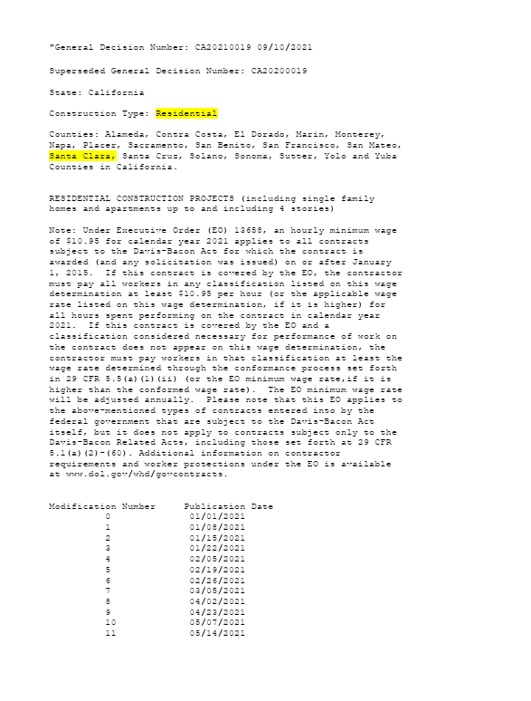

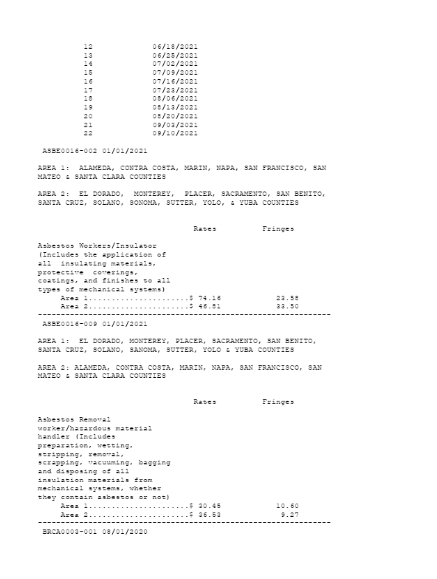

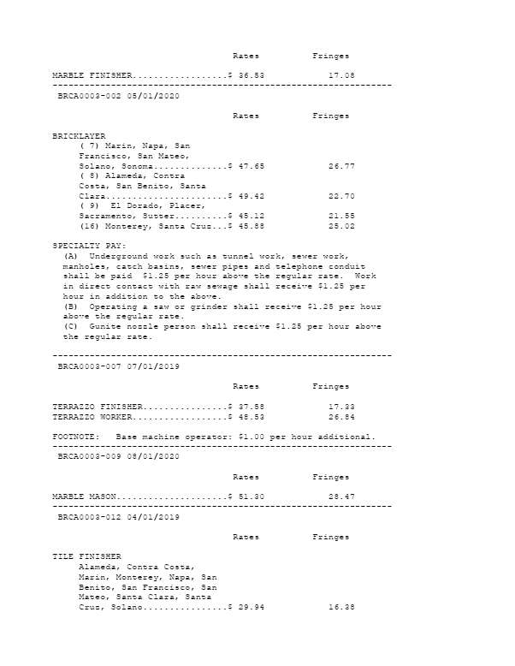

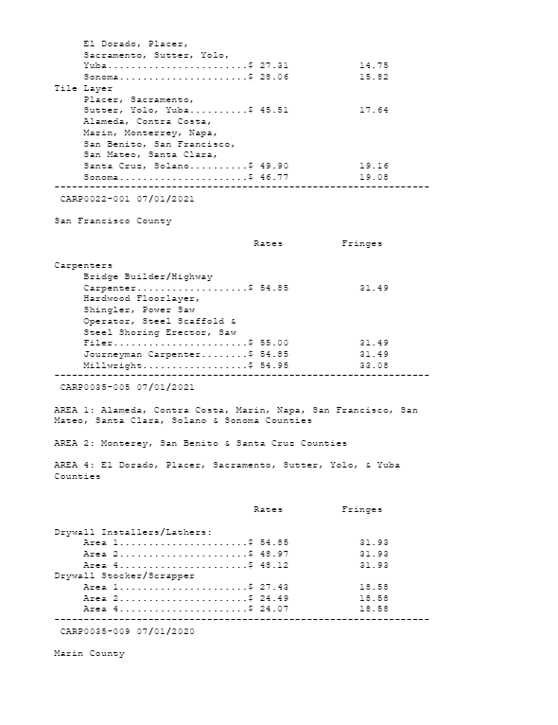
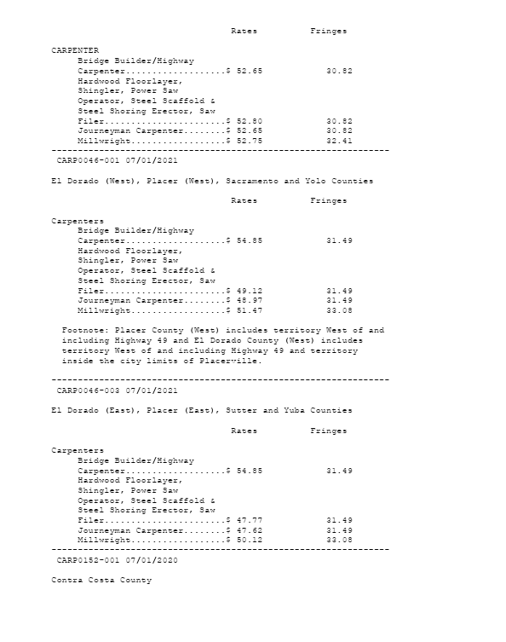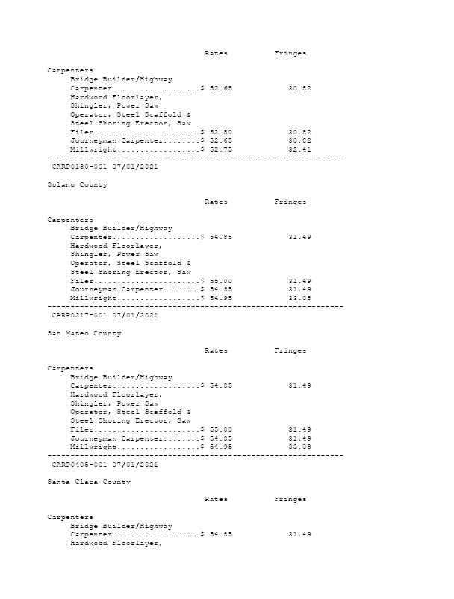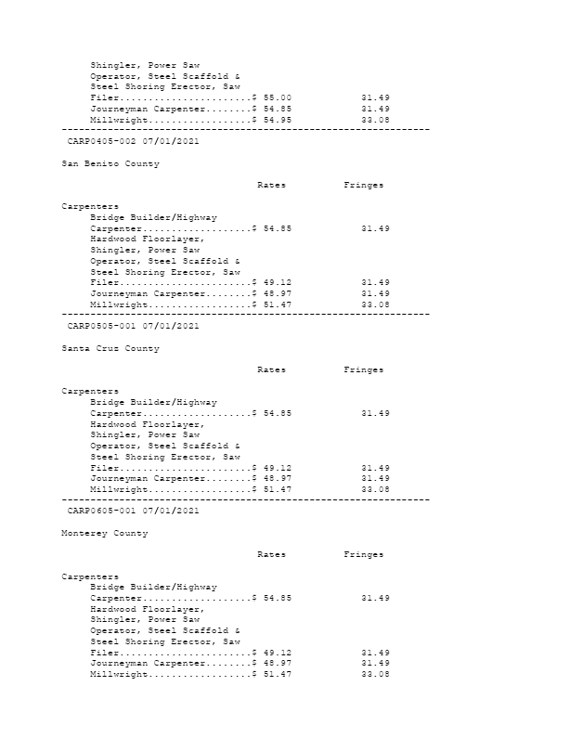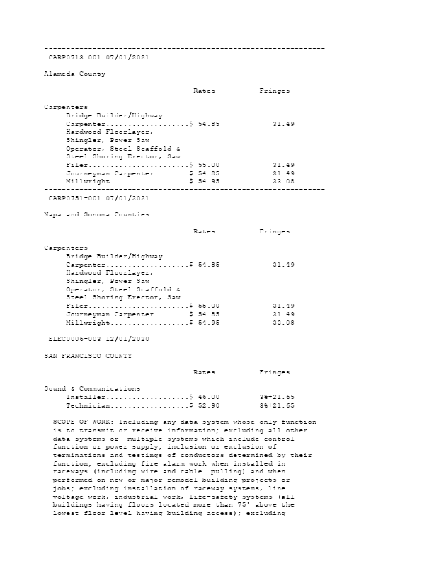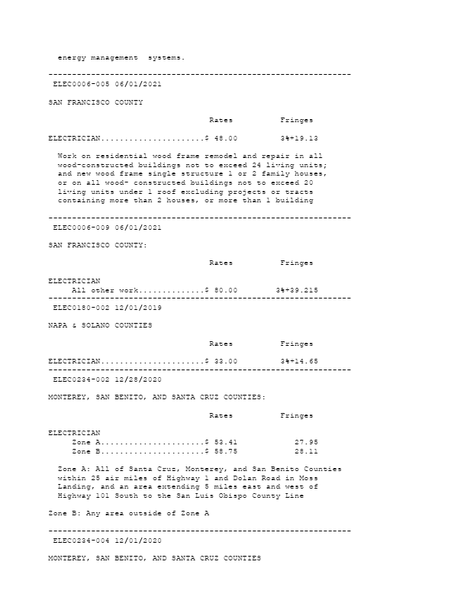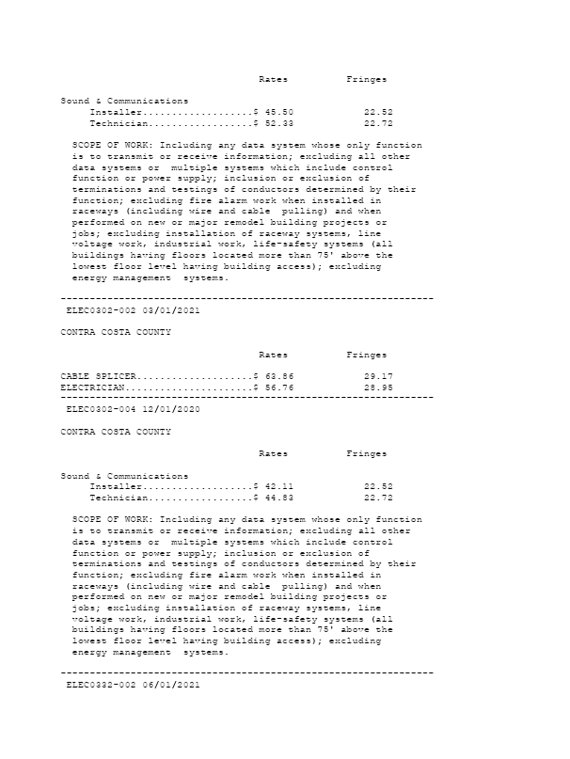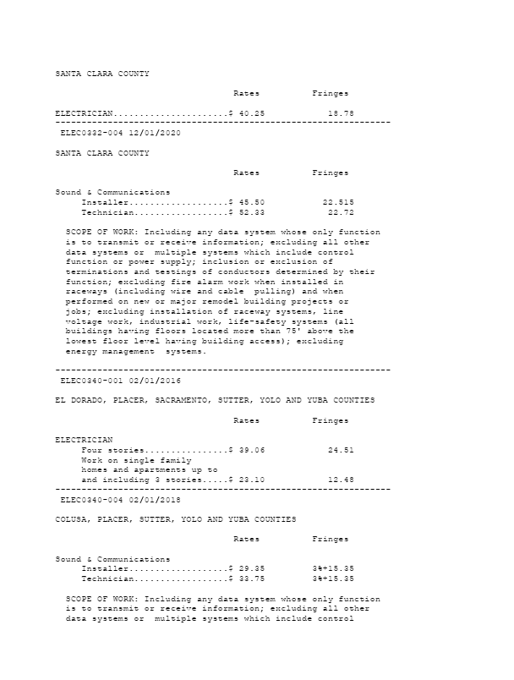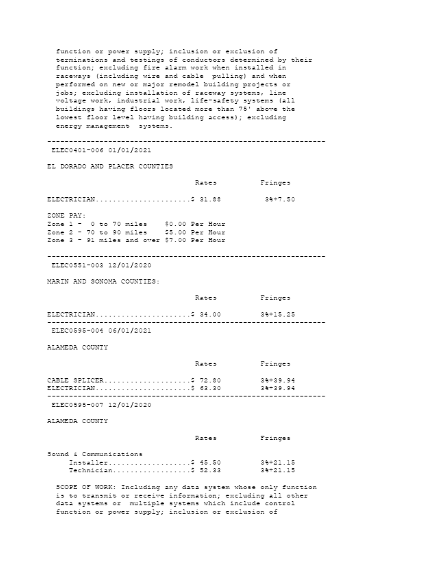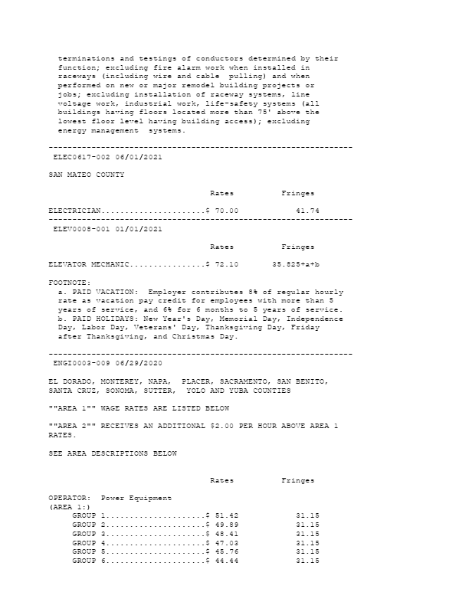
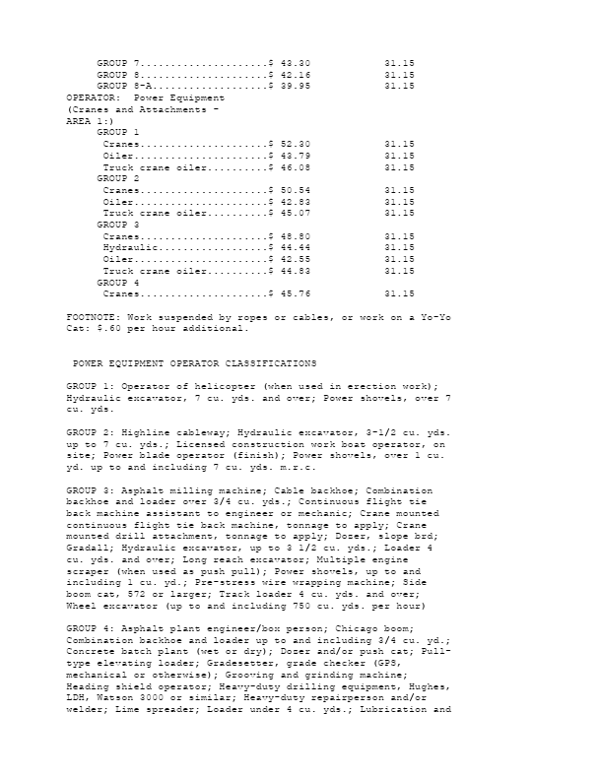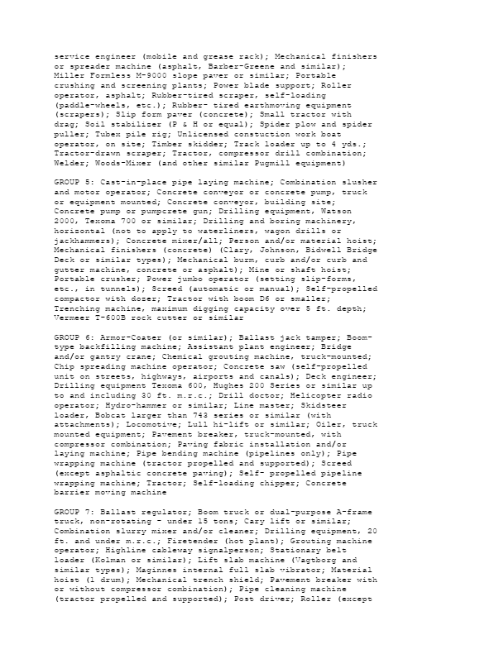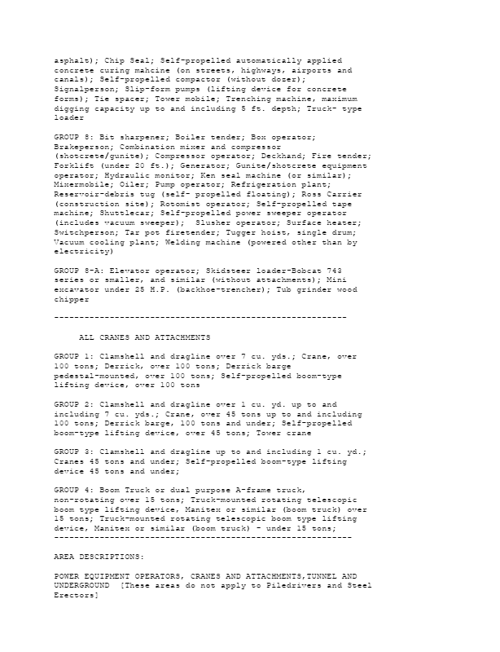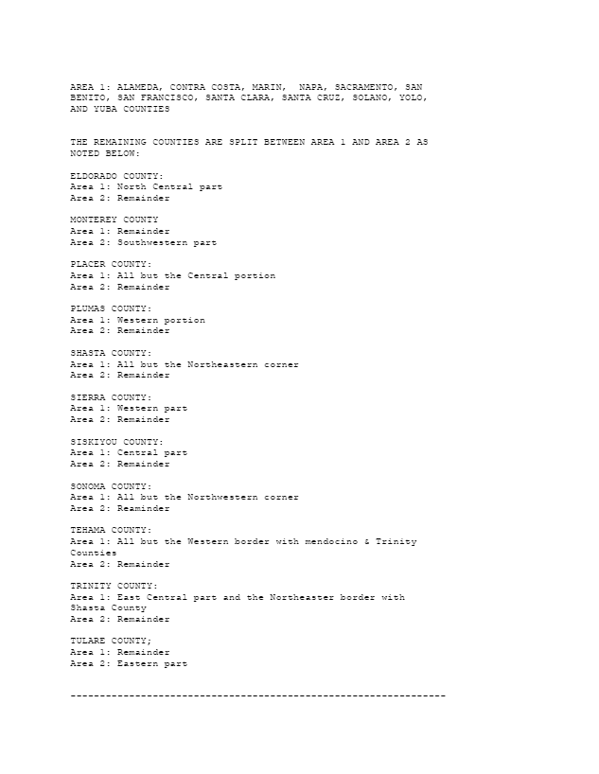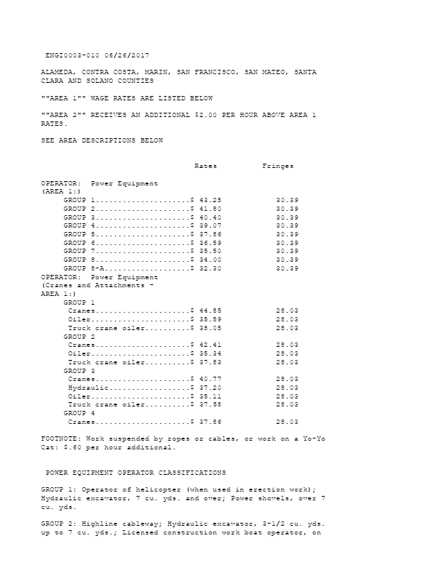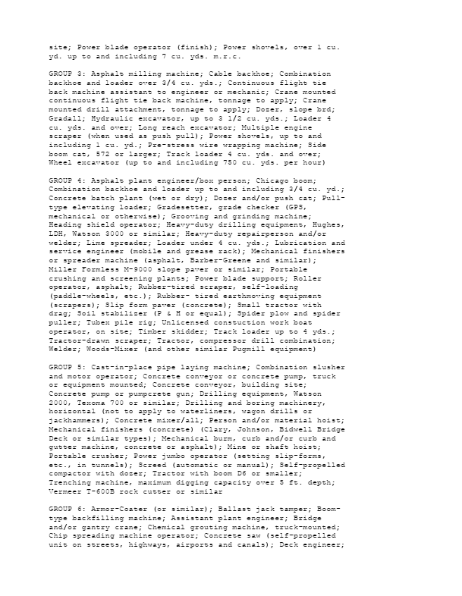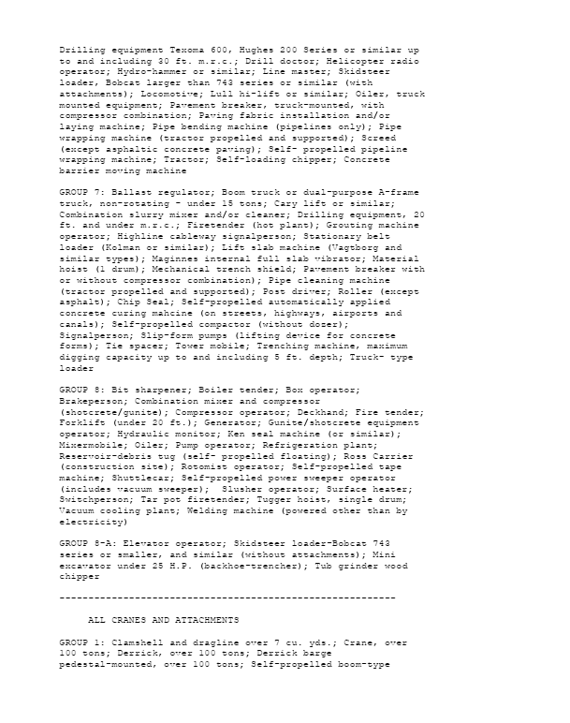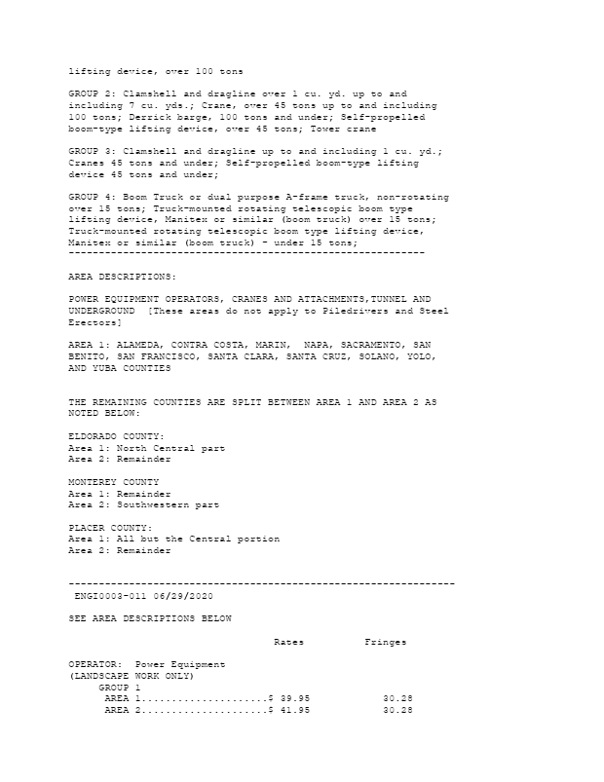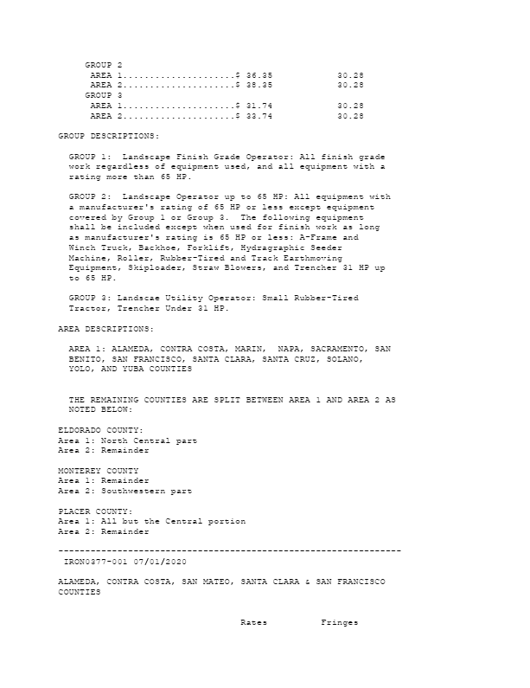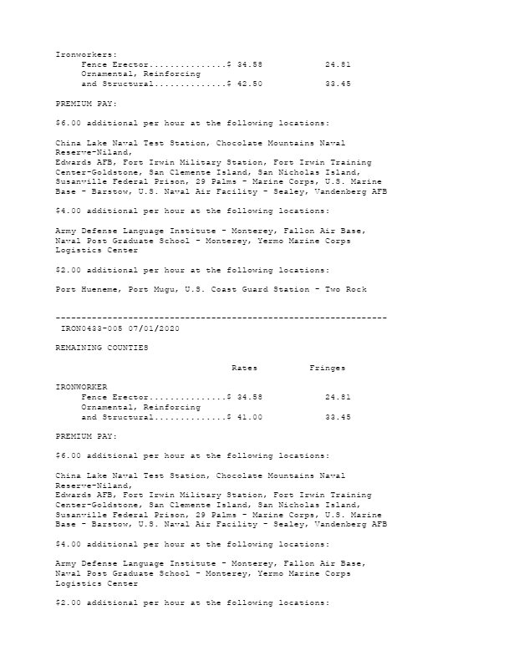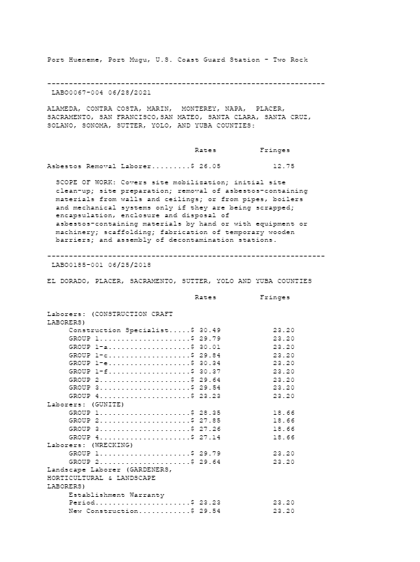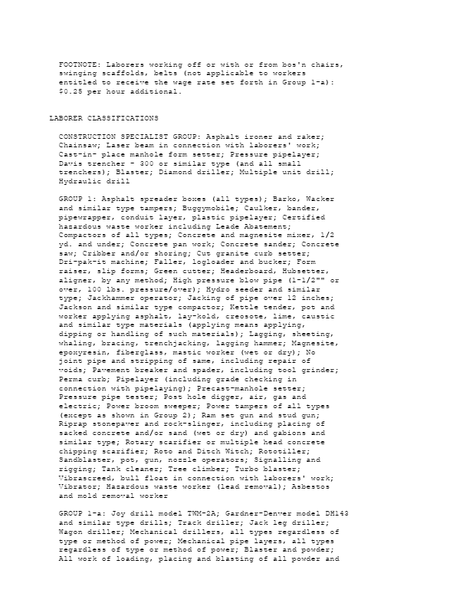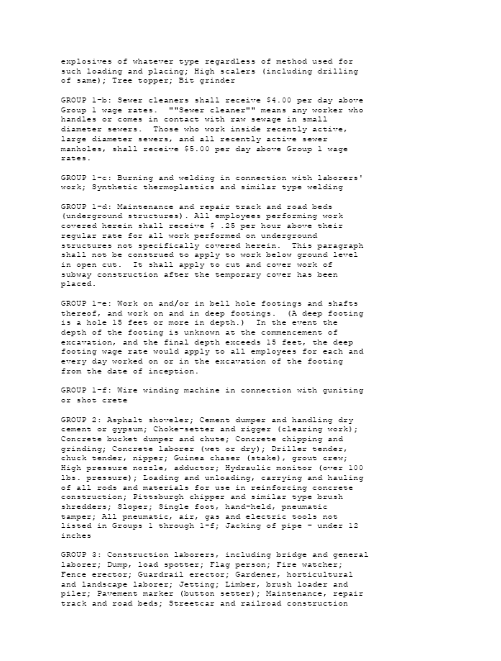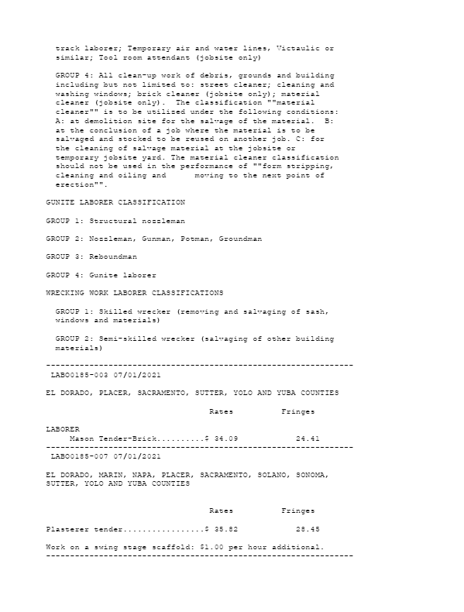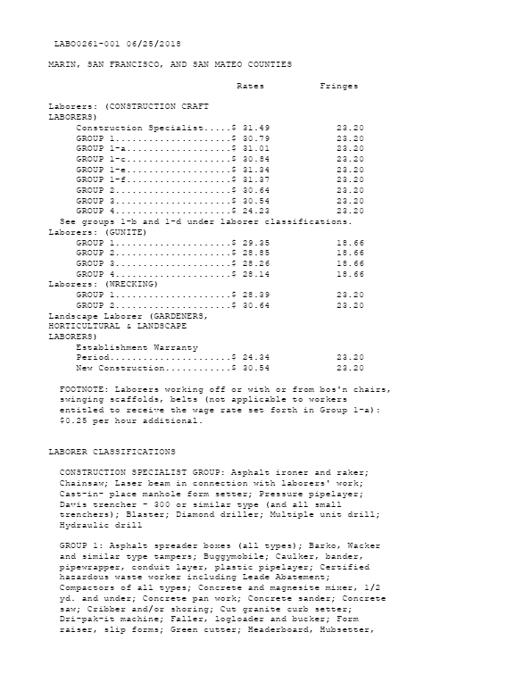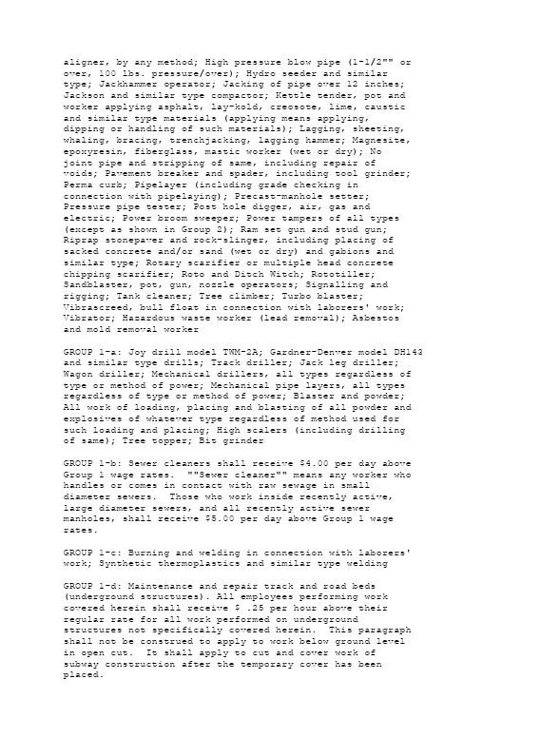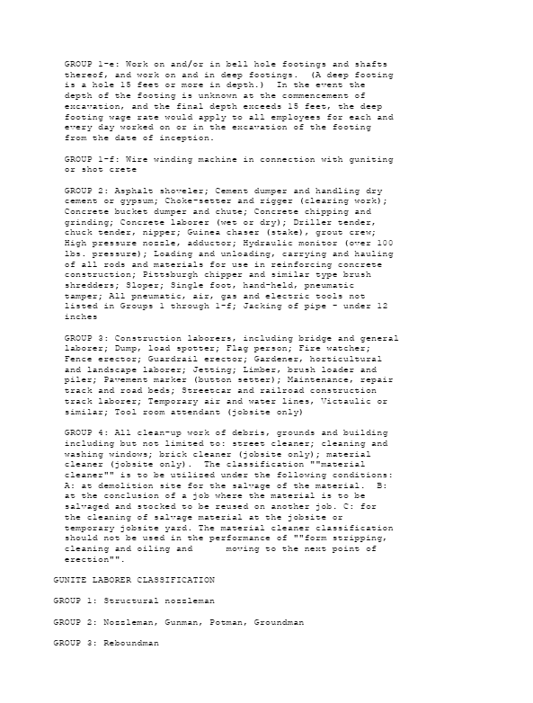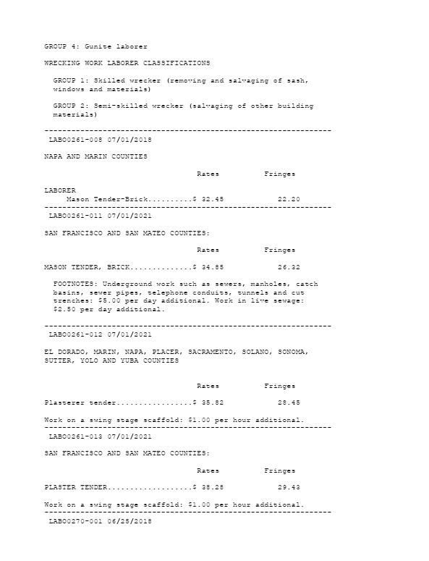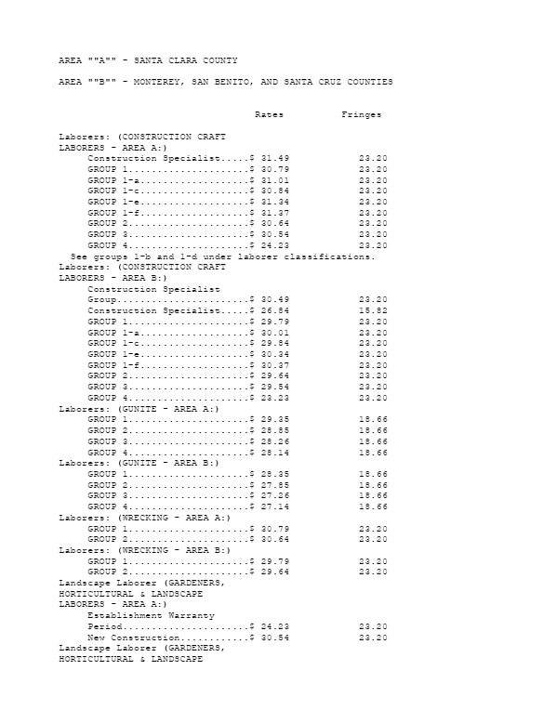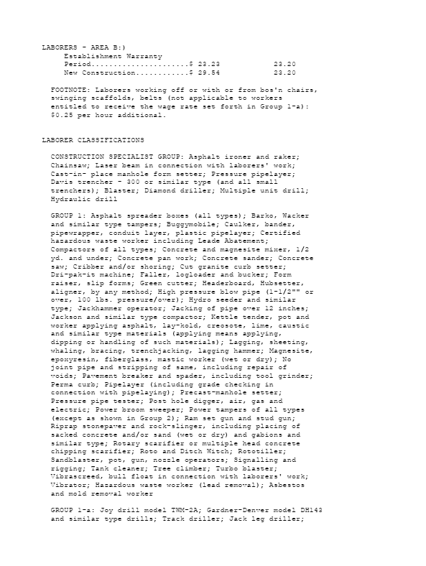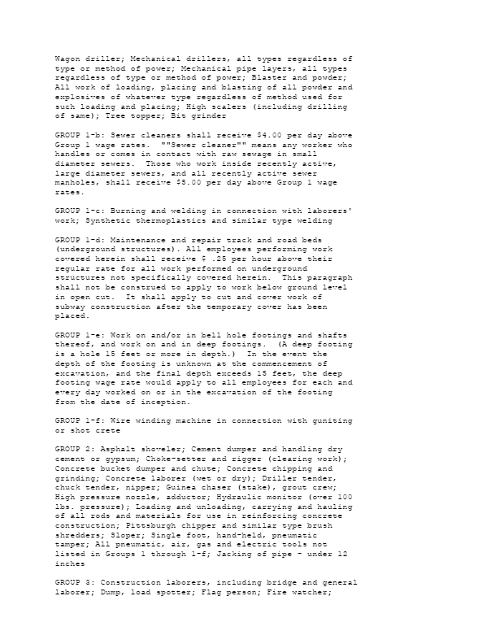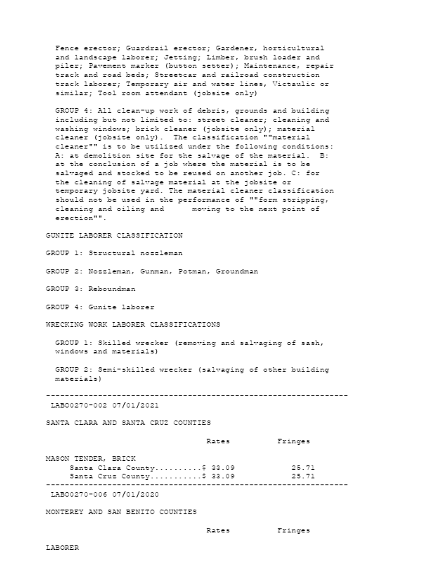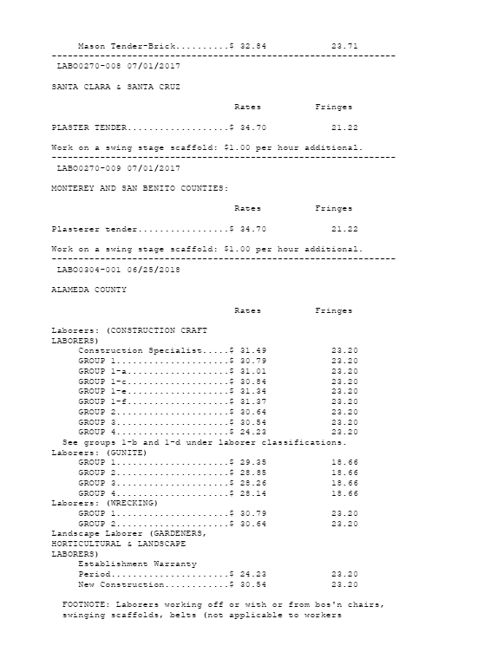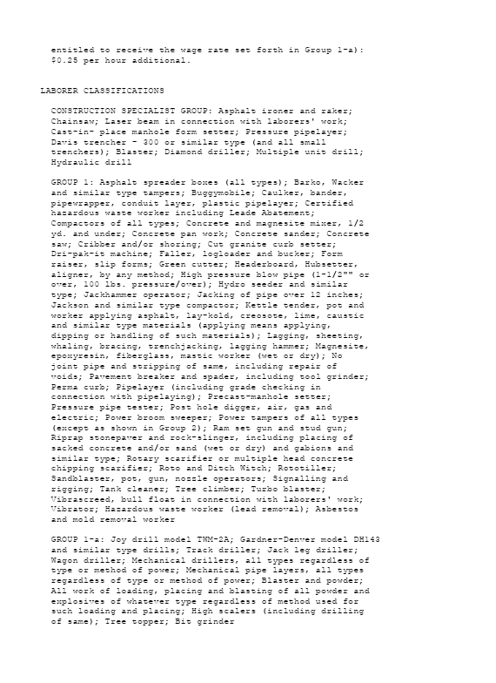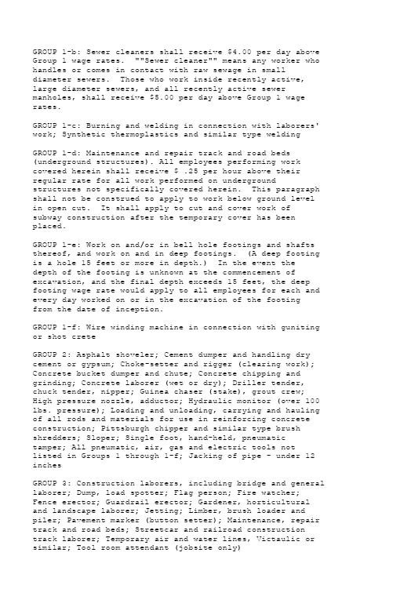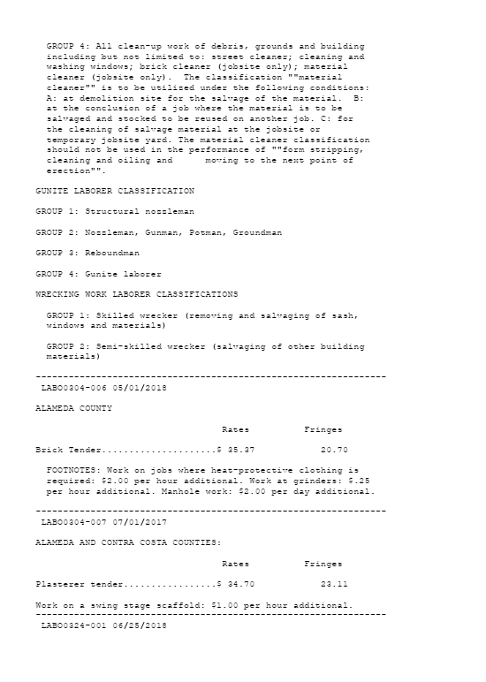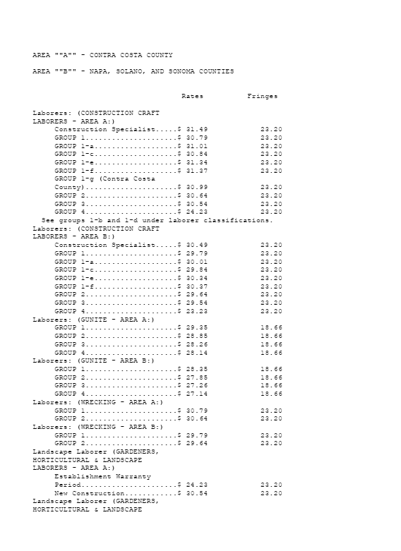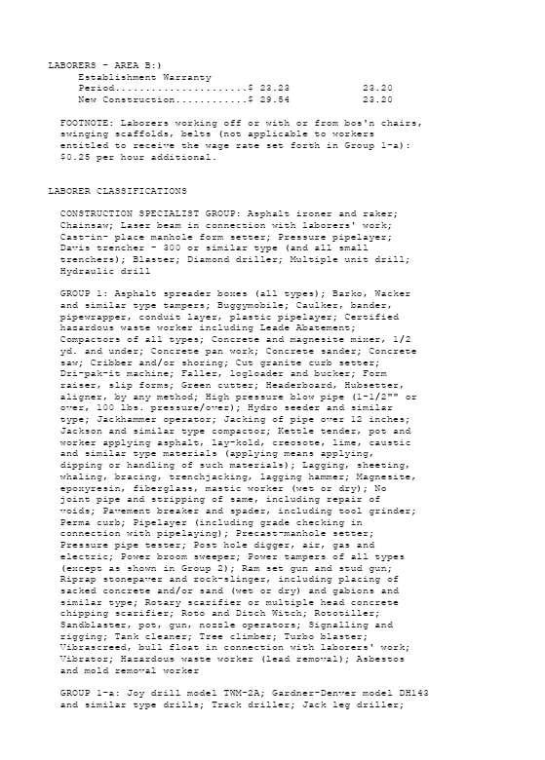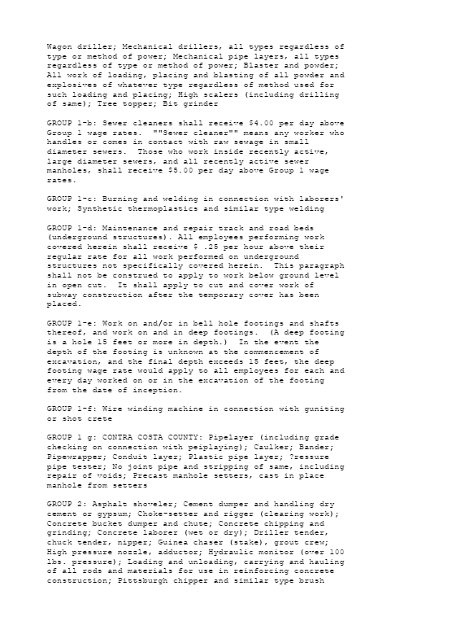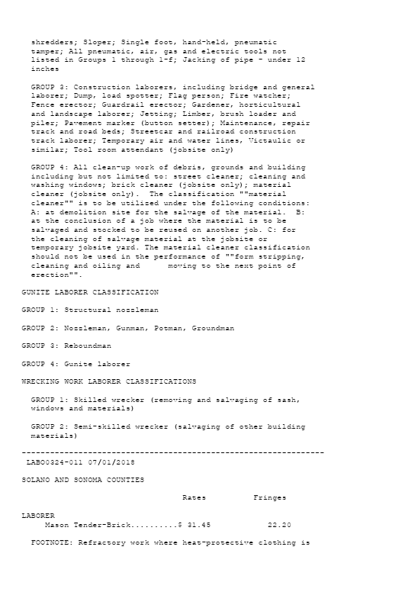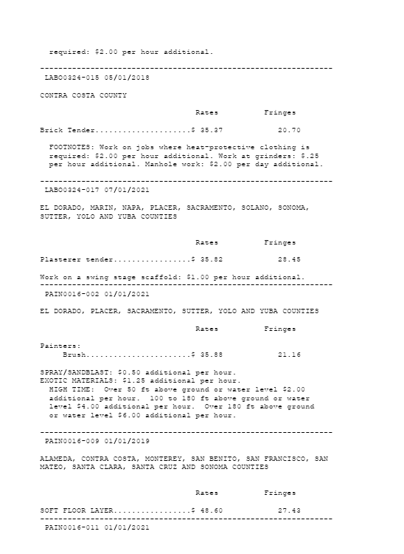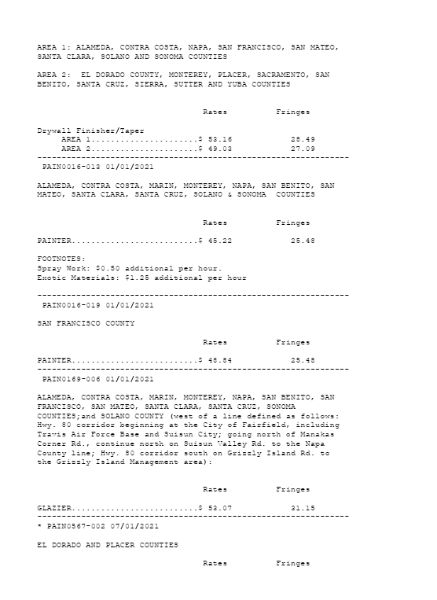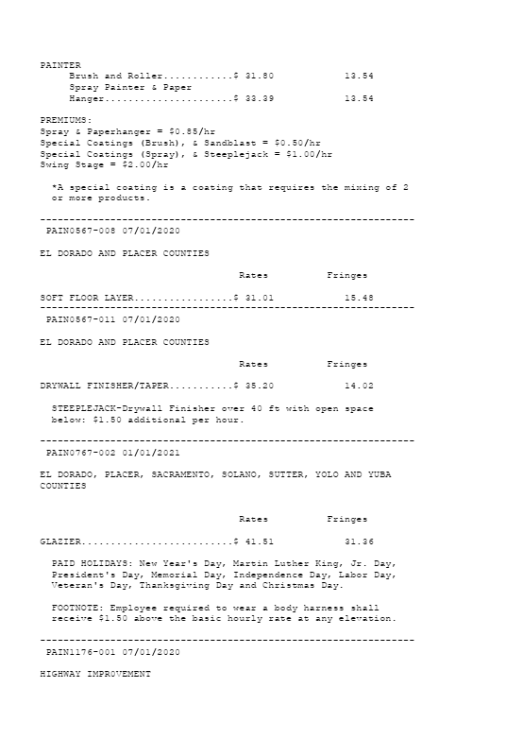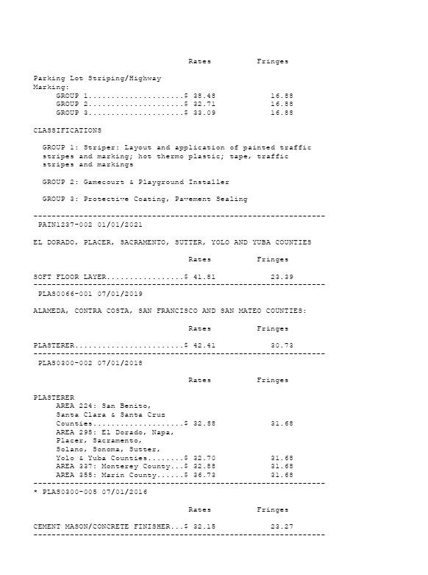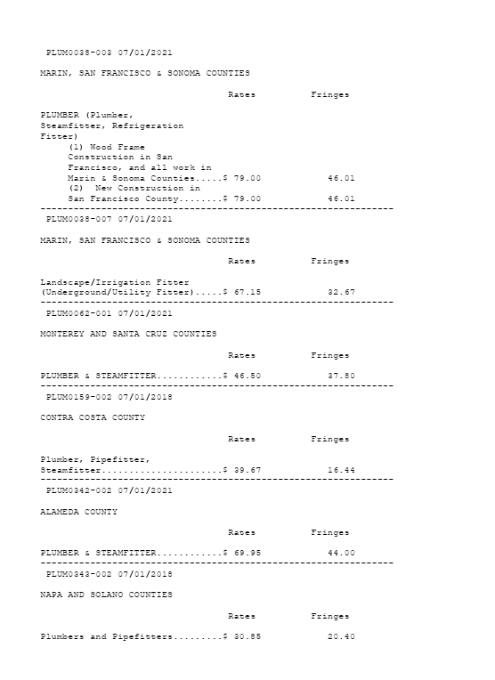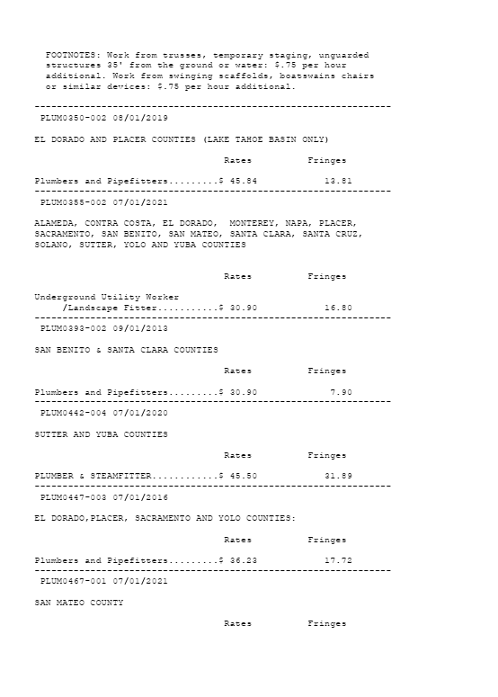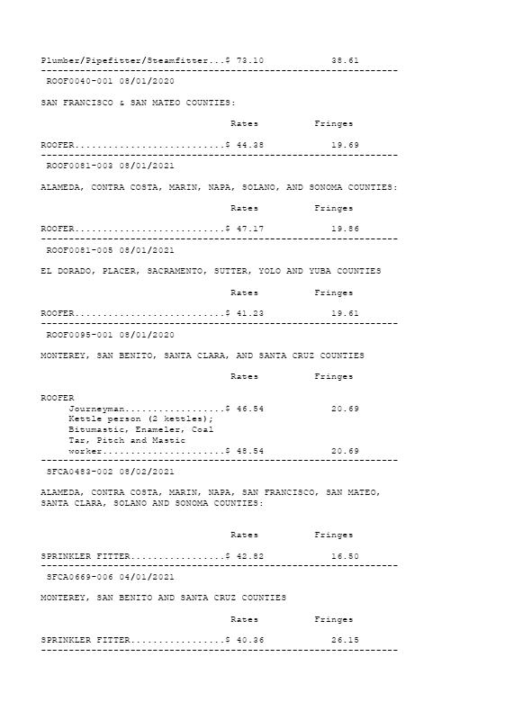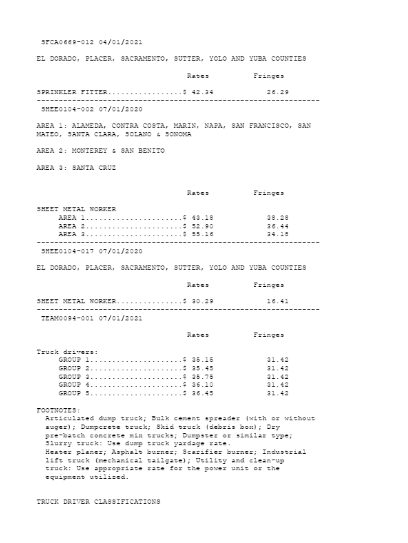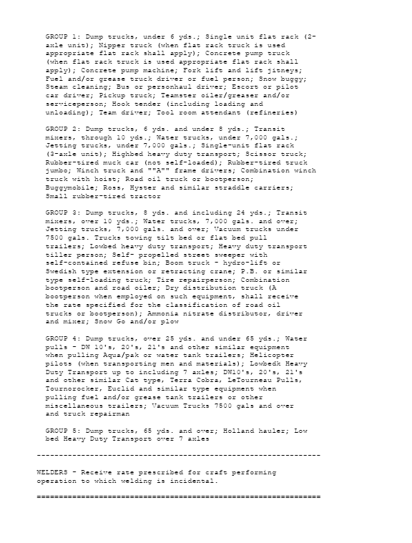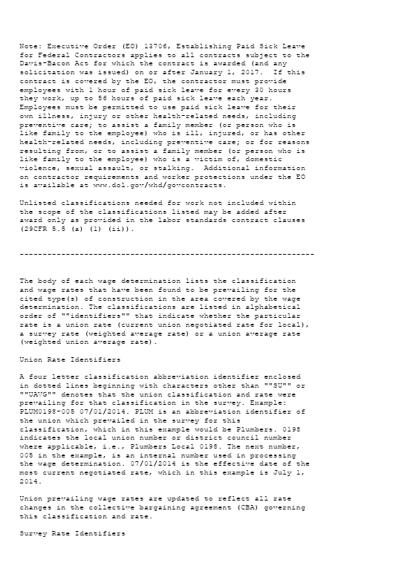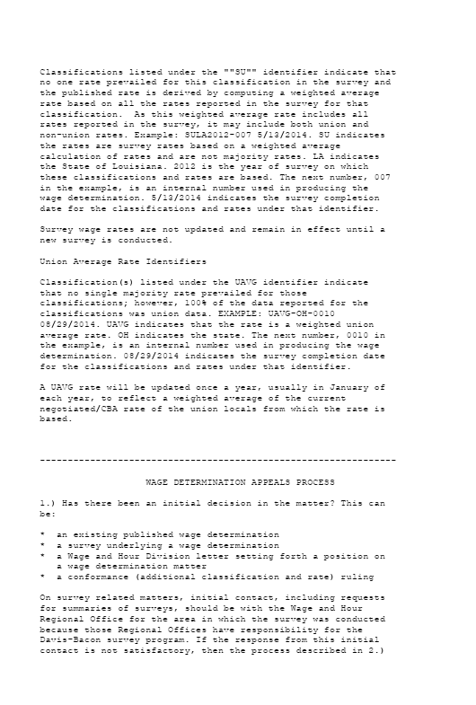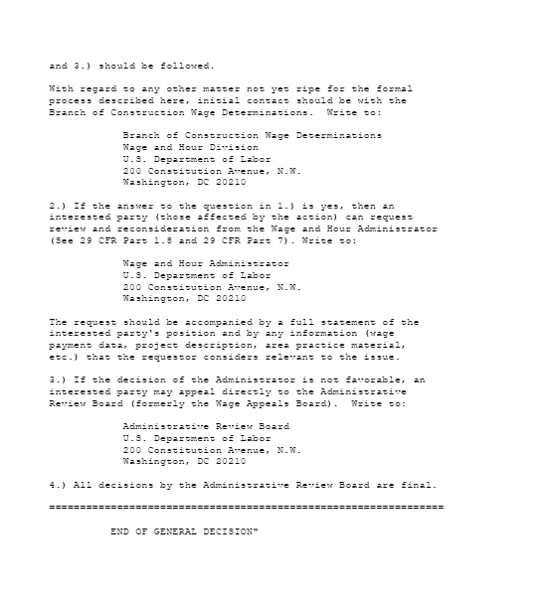

Signature _____________ Date:
Printed Name: Company Name:

